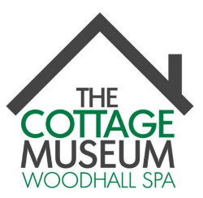

Volunteer Morning

We offer an opportunity to meet new people and make new friends.

We are looking for volunteers aged 18 – 88 for the following:

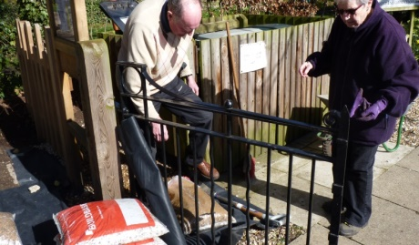

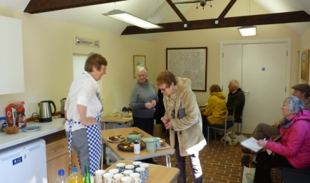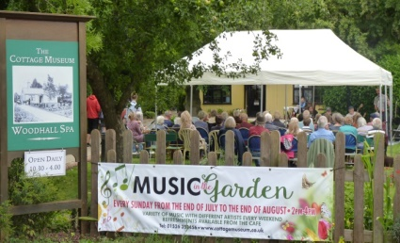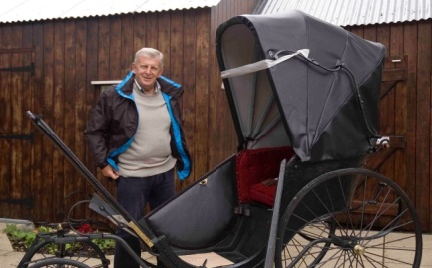

Education DIY/Maintenance Gardening Social Media Displays

Fund Raising Collection Care Marketing Museum Guides

**Why not pop in and have a chat at with current Volunteers and Trustees at**

**The Cottage Museum**

**Iddesleigh Road**

**Woodhall Spa LN10 6SH**

**Saturday 22nd February 0900 - 1200**